**Unit Project One:**

Geometric Properties of Triangles

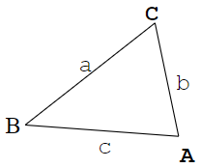

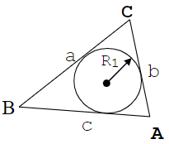

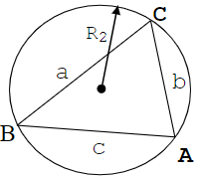

**PROGRAM**

The program is 220 lines long

// ____ __ __

// / / \ / \

// / / /

// / \___/ \___/

//

// Date: 9/21/2021

// Name: David Vermaak

//Project Description: This program takes the three sides of a triangle and calculates various Geometric

// properties of the triangle, including the area, incircle radius, circumcircle radius, and remaining area

// Inputs: The three sides of a triangle

// Outputs: Three angles (rad or deg), Area (units^2), and radius (units)

//*************************************************************

#include <iostream> //This header containing cout and cin

#include <conio.h> //This header declares getch which pauses until a key is pushed

#include <math.h> //This header allows for the use of more complex mathmatical operators

#include <string> //This header enables string functions

#include <cctype> //This header contains functions that give boolian answers for given types of char

#include <iomanip> //This header contains functions to better format output

using namespace std; //introduces namespace std

int main ( )

{

// initalizes the variables of the sides and angles of the triangle

double side_A, side_B, side_C, angle_A, angle_B, angle_C;

// initalizes the variables of the Area, incircle radius, circumcircle radius, and remaining area

double Area, AreaIR, AreaOR, InRadius, OutRadius, rArea, s;

// sets up a constant for the value of pi

const float pi = acos(-1.0);

//initalizes a variable for the menu

int choice;

//initalizes a character used to choose radian or degree output

char angle;

string Angle = " radians ";

//initalizes a string used to choose the units for the output

string units;

// prompt user for input

cout << "This program takes the three sides of a triangle and calculates various Geometric properties"

<< "\n\nPlease enter the units your side lengths are in, ex. meters\n";

cin >> units;

units = " " + units; //adds a space before the string for better legibility

cout << "Please enter the three side lengths of your triangle:\n\n";

cout <<" C \n"; //provides the user with a visual of the triangle

cout <<" / \\ \n"; //this helps with understanding where the angles and sides are

cout <<" / \\ \n"; //in relation to each other

cout <<" a/ \\b \n";

cout <<" / \\ \n";

cout <<" /_________\\ \n";

cout <<" B c A \n\n\n";

cout << "side a: ";

cin >> side_A;

cout << "\n side b: ";

cin >> side_B;

cout << "\n side c: ";

cin >> side_C;

//this statement checks if the values that were entered are within acceptable parameters

if (side_A < 0 || side_B < 0 || side_C < 0 )

{ cout << "\n Error.\n A negative value for any of the triangles sides is not allowed.\n Program terminated.";

return 1; }

else if (side_A > (side_B + side_C) || side_B > (side_A + side_C) || side_C > (side_B + side_A) )

{ cout << "\n Error.\n One of the sides of the triangle exceeds parameters.\n Program terminated.";

return 1; }

else

//calculates the angles by law of sines

angle_A = acos((pow(side_B, 2) + pow(side_C, 2) - pow(side_A, 2))/(2 * side_B * side_C));

angle_B = acos((pow(side_A, 2) + pow(side_C, 2) - pow(side_B, 2))/(2 * side_A * side_C));

//pi is the total number of radians in a triangle so c = total-(a+b)

angle_C = (pi)-(angle_A + angle_B);

//initial calculations of the area using s, the semi-perimeter (Heron's Formula)

s = 0.5*(side_A + side_B + side_C);

Area = sqrt(s*(s-side_A)*(s-side_B)*(s-side_C));

do //creates a loop for the menu that returns the user here after each switch choice

{

// display menu

cout << "\n\nPlease choose one of the following options to continue: (1,2,3,4)\n";

cout << "(1): Find the 3 angles of the triangle, and the triangle area \n";

cout << "(2): Find the largest incircle radius, and the remaining interior area of the triangle \n";

cout << "(3): Find the circumcircle radius, and the remaining interior area of the circumcircle \n";

cout << "(4): Quit \n\n";

cout << "Enter your choice:";

//get user input for use in the switch choice

cin >> choice;

cout << "\n";

switch(choice) //easy way to set up a menu where it jumps to the correct line

//depending on the value of choice the user inputs

{

case 1:

cout << "Would you like the angles displayed in radians (r) or degrees (d)?\n (r or d): \n\n";

cin >> angle;

if (angle == 'd') //if user wants degrees will convert radians to degrees

{

angle_A = angle_A * ( 180/ pi);

angle_B = angle_B * ( 180/ pi);

angle_C = angle_C * ( 180/ pi);

Angle = " degrees ";

}

//visual output for the user that allows for better understanding of the other outputs

cout <<" C \n";

cout <<" / \\ \n";

cout <<" / \\ \n";

cout <<" a/ \\b \n";

cout <<" / \\ \n";

cout <<" /_________\\ \n";

cout <<" B c A \n\n\n";

cout << "The three angles are A = " << angle_A << Angle

<< " B = " << angle_B << Angle

<< " and C = " << angle_C << Angle

<< "\nThe area of the triangle is: " << Area << units << " squared"

<<" \n \n To return to the menu press enter";

getch(); //pauses until a key is pressed

system("cls"); //clears the console screen

break; //goes to the end of the switch statement

case 2:

cout << " Finding the largest incircle radius, and the remaining interior area of the triangle\n";

InRadius = ((2 * Area)/(side_A + side_B + side_C));

AreaIR = pi * (pow(InRadius, 2));

rArea = Area - AreaIR;

//visual output for the user that allows for better understanding of the other outputs

cout <<" C \n";

cout <<" / \\ \n";

cout <<" / \\ \n";

cout <<" a/ . \\b \n";

cout <<" /. R1 .\\ \n";

cout <<" /. .-->.\\ \n";

cout <<" / . . \\ \n";

cout <<" / . \\ \n";

cout <<" /_______________\\ \n";

cout <<" B c A \n\n\n";

cout << "The largest incircle radius is: " << InRadius << units

<< " \nand the remaining interior area of the triangle = " << rArea << units << " squared"

<< "\n \n To return to the menu press enter";

getch();

system("cls");

break;

case 3:

OutRadius = sqrt((side_A * side_B * side_C)/((side_A + side_B + side_C) * (side_B + side_C - side_A) * (side_C + side_A - side_B) * (side_A + side_B - side_C)));

AreaOR = pi * (pow(OutRadius, 2));

rArea = Area - AreaOR;

//visual output for the user that allows for better understanding of the other outputs

cout <<" . \n";

cout <<" . ^ C . \n";

cout <<" /|\\ \n";

cout <<" . / | \\ . \n";

cout <<" a/ | \\b \n";

cout <<" . / | \\ . \n";

cout <<" / *R2 \\ \n";

cout <<" . / \\ . \n";

cout <<" / \\ \n";

cout <<" . /_______________\\ \n";

cout <<" B c A \n";

cout <<" . . \n";

cout <<" . \n";

cout <<" \n";

cout << "\n \n The circumcircle radius is: " << OutRadius << " \nand the remaining interior area of the circumcircle = " << rArea << units << " squared";

cout << "\n \n To return to the menu press enter";

getch();

system("cls");

break;

default: //catch-all case that ends the program if any number other than (1,2,3) is entered

cout << "Program has ended\n";

return 0;

}

}

while(choice != 1 || 2 || 3); //keeps the loop going while conditions are right

return 0;

}

**PROGRAM Flowchart:**

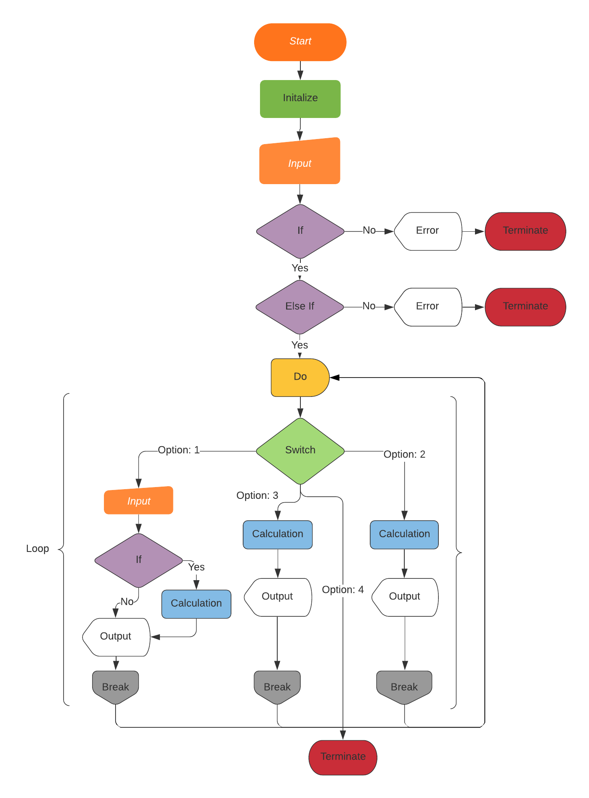

* Test Results: Run the program for the following 10 test cases:
* Option 1: a = 20, b = 15, c = 10 (example)

This program takes the three sides of a triangle and calculates various Geometric properties

Please enter the units your side lengths are in, ex. meters

feet

Please enter the three side lengths of your triangle:

C

/ \

/ \

a/ \b

/ \

/_________\

B c A

side a: 20

side b: 15

side c: 10

Please choose one of the following options to continue: (1,2,3,4)

(1): Find the 3 angles of the triangle, and the triangle area

(2): Find the largest incircle radius, and the remaining interior area of the triangle

(3): Find the circumcircle radius, and the remaining interior area of the circumcircle

(4): Quit

Enter your choice :1

Would you like the angles displayed in radians (r) or degrees (d)?

(r or d):

d

The three angles are A = 104.478 degrees B = 46.5675 degrees and C = 28.955 degrees

The area of the triangle is: 72.6184 feet squared

To return to the menu press enter

Option 2: a = 20, b = 15, c = 10 (example)

Enter your choice :2

Finding the largest incircle radius, and the remaining interior area of the triangle

C

/ \

/ \

a/ . \b

/. R1 .\

/. .-->.\

/ . . \

/ . \

/_______________\

B c A

The largest incircle radius is: 3.22749 feet

and the remaining interior area of the triangle = 39.8935 feet squared

To return to the menu press enter

Option 3: a = 20, b = 15, c = 10 (example)

Enter your choice :3

.

. ^ C .

/|\

. / | \ .

a/ | \b

. / | \ .

/ *R2 \

. / \ .

/ \

. /_______________\

B c A

. .

.

The circumcircle radius is: 0.188562

and the remaining interior area of the circumcircle = 72.5067 feet squared

To return to the menu press enter

* Option 1: a = 20, b = 15, c = 25

This program takes the three sides of a triangle and calculates various Geometric properties

Please enter the units your side lengths are in, ex. meters

meters

Please enter the three side lengths of your triangle:

C

/ \

/ \

a/ \b

/ \

/_________\

B c A

side a: 20

side b: 15

side c: 25

Please choose one of the following options to continue: (1,2,3,4)

(1): Find the 3 angles of the triangle, and the triangle area

(2): Find the largest incircle radius, and the remaining interior area of the triangle

(3): Find the circumcircle radius, and the remaining interior area of the circumcircle

(4): Quit

Enter your choice :1

Would you like the angles displayed in radians (r) or degrees (d)?

(r or d):

r

C

/ \

/ \

a/ \b

/ \

/_________\

B c A

The three angles are A = 0.927295 radians B = 0.643501 radians and C = 1.5708 radians

The area of the triangle is: 150 meters squared

To return to the menu press enter

Option 2: a = 20, b = 15, c = 25

Enter your choice :2

Finding the largest incircle radius, and the remaining interior area of the triangle

C

/ \

/ \

a/ . \b

/. R1 .\

/. .-->.\

/ . . \

/ . \

/_______________\

B c A

The largest incircle radius is: 5 meters

and the remaining interior area of the triangle = 71.4602 meters squared

To return to the menu press enter

Option 3: a = 20, b = 15, c = 25

Enter your choice :3

.

. ^ C .

/|\

. / | \ .

a/ | \b

. / | \ .

/ *R2 \

. / \ .

/ \

. /_______________\

B c A

. .

.

The circumcircle radius is: 0.144338

and the remaining interior area of the circumcircle = 149.935 meters squared

To return to the menu press enter

* Option 1: a = 14, b = 15, c = 16

This program takes the three sides of a triangle and calculates various Geometric properties

Please enter the units your side lengths are in, ex. meters

parsec

Please enter the three side lengths of your triangle:

C

/ \

/ \

a/ \b

/ \

/_________\

B c A

side a: 14

side b: 15

side c: 16

Please choose one of the following options to continue: (1,2,3,4)

(1): Find the 3 angles of the triangle, and the triangle area

(2): Find the largest incircle radius, and the remaining interior area of the triangle

(3): Find the circumcircle radius, and the remaining interior area of the circumcircle

(4): Quit

Enter your choice :1

Would you like the angles displayed in radians (r) or degrees (d)?

(r or d):

d

C

/ \

/ \

a/ \b

/ \

/_________\

B c A

The three angles are A = 53.5764 degrees B = 59.556 degrees and C = 66.8676 degrees

The area of the triangle is: 96.5579 parsec squared

To return to the menu press enter

Option 2: a = 14, b = 15, c = 16

Enter your choice :2

Finding the largest incircle radius, and the remaining interior area of the triangle

C

/ \

/ \

a/ . \b

/. R1 .\

/. .-->.\

/ . . \

/ . \

/_______________\

B c A

The largest incircle radius is: 4.29146 parsec

and the remaining interior area of the triangle = 38.7003 parsec squared

To return to the menu press enter

Option 3: a = 14, b = 15, c = 16

Enter your choice :3

.

. ^ C .

/|\

. / | \ .

a/ | \b

. / | \ .

/ *R2 \

. / \ .

/ \

. /_______________\

B c A

. .

.

The circumcircle radius is: 0.15008

and the remaining interior area of the circumcircle = 96.4872 parsec squared

To return to the menu press enter

* Discussion
  + Program performance:

The program’s performance was really only limited by the amount of time I was willing to spend on it which was a significant amount.

* + Extra credit features include:

A) Displayed three different diagrams

B) Made a looping menu

C) User can enter units of their choice

D) User can choose between degrees and radians for angle output for option 1

* + Potential improvements:

There were several features that I didn’t add in only because it would be a pain to add them to the flowchart and or program. For example, I was thinking of adding in another loop to the program so that you could re-enter the side lengths instead of having to rerun it. Additionally, I was also thinking of adding a ‘s’ to the end of the “unit” string if the user did not, using an if(unit[(string.length-1)] != ‘s’) statement, but I did not.